MCA Semester - II
CAUC514: Full Stack Web Development
ID=25MCA090
Name=Krish Manavadariya
Practical Assignment 3
1. Write a Node.js program that outputs "Hello, Node.js!" to the console.
Code:
var http = require('http');

http.createServer(function(req, res) {
res.write("Hello from Server");
res.end();
}).listen(5000);

console.log("Server running...");

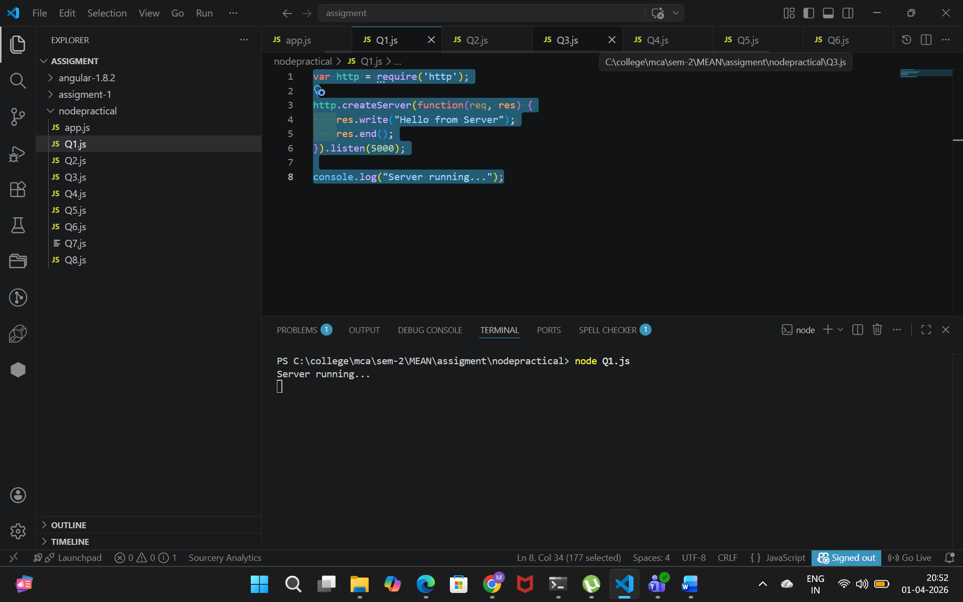

Output:
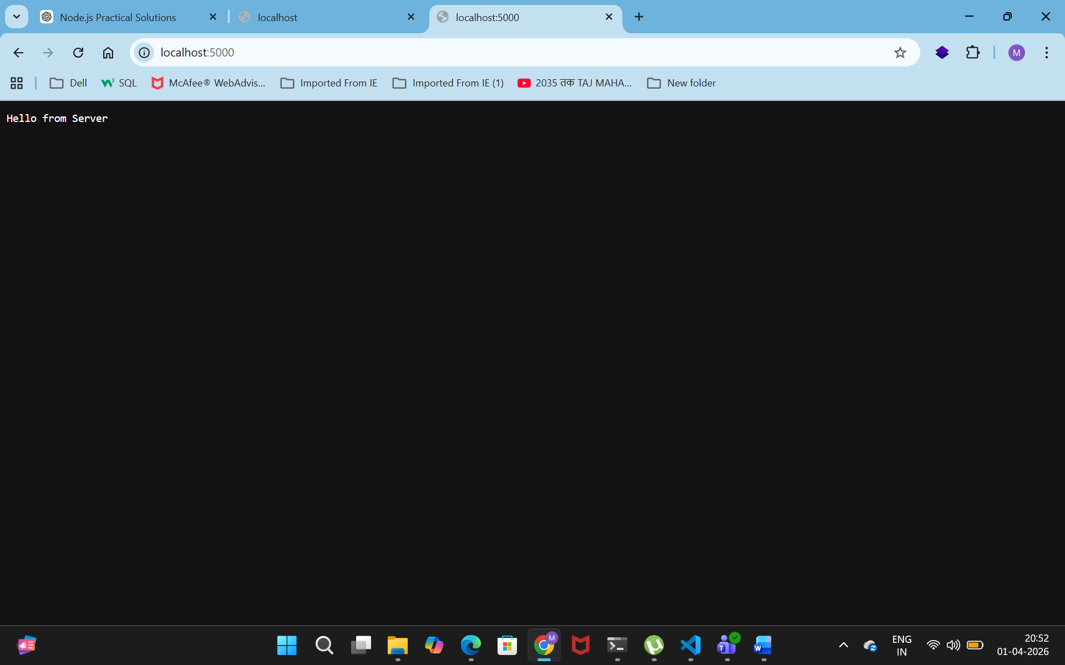

2. Write a Node.js program that accepts course details as arguments and displays the course details to the console.

Code:
var args = process.argv;
var even = 0;
var odd = 0;

for(var i = 2; i < args.length; i++) {
var num = parseInt(args[i]);

if(num % 2 == 0)
even++;
else
odd++;
}

console.log("Even Count: " + even);
console.log("Odd Count: " + odd);

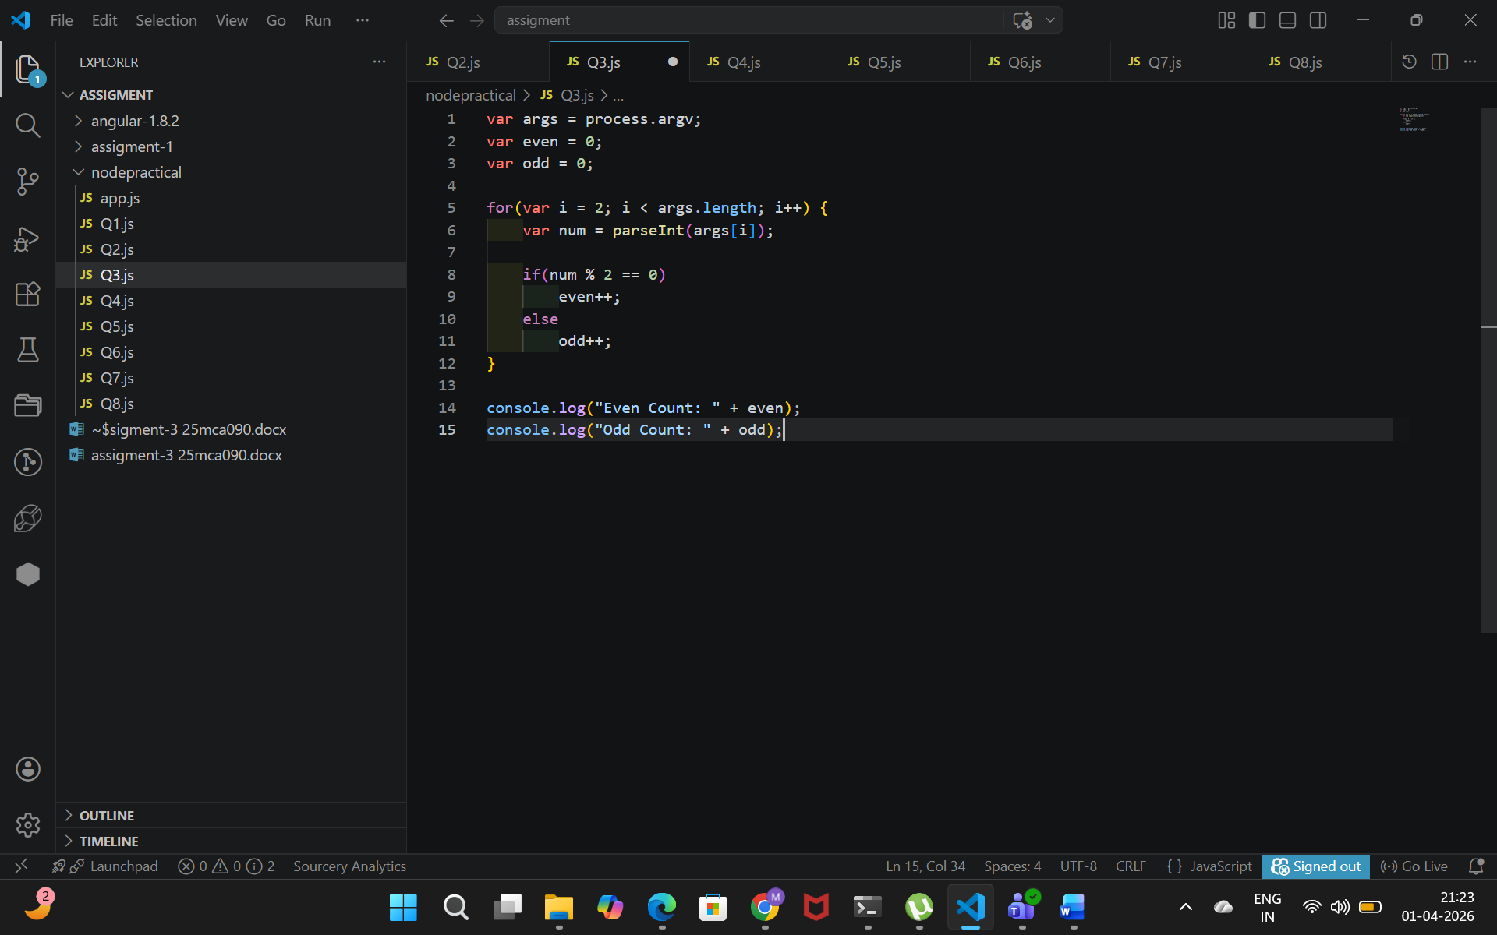

Output:
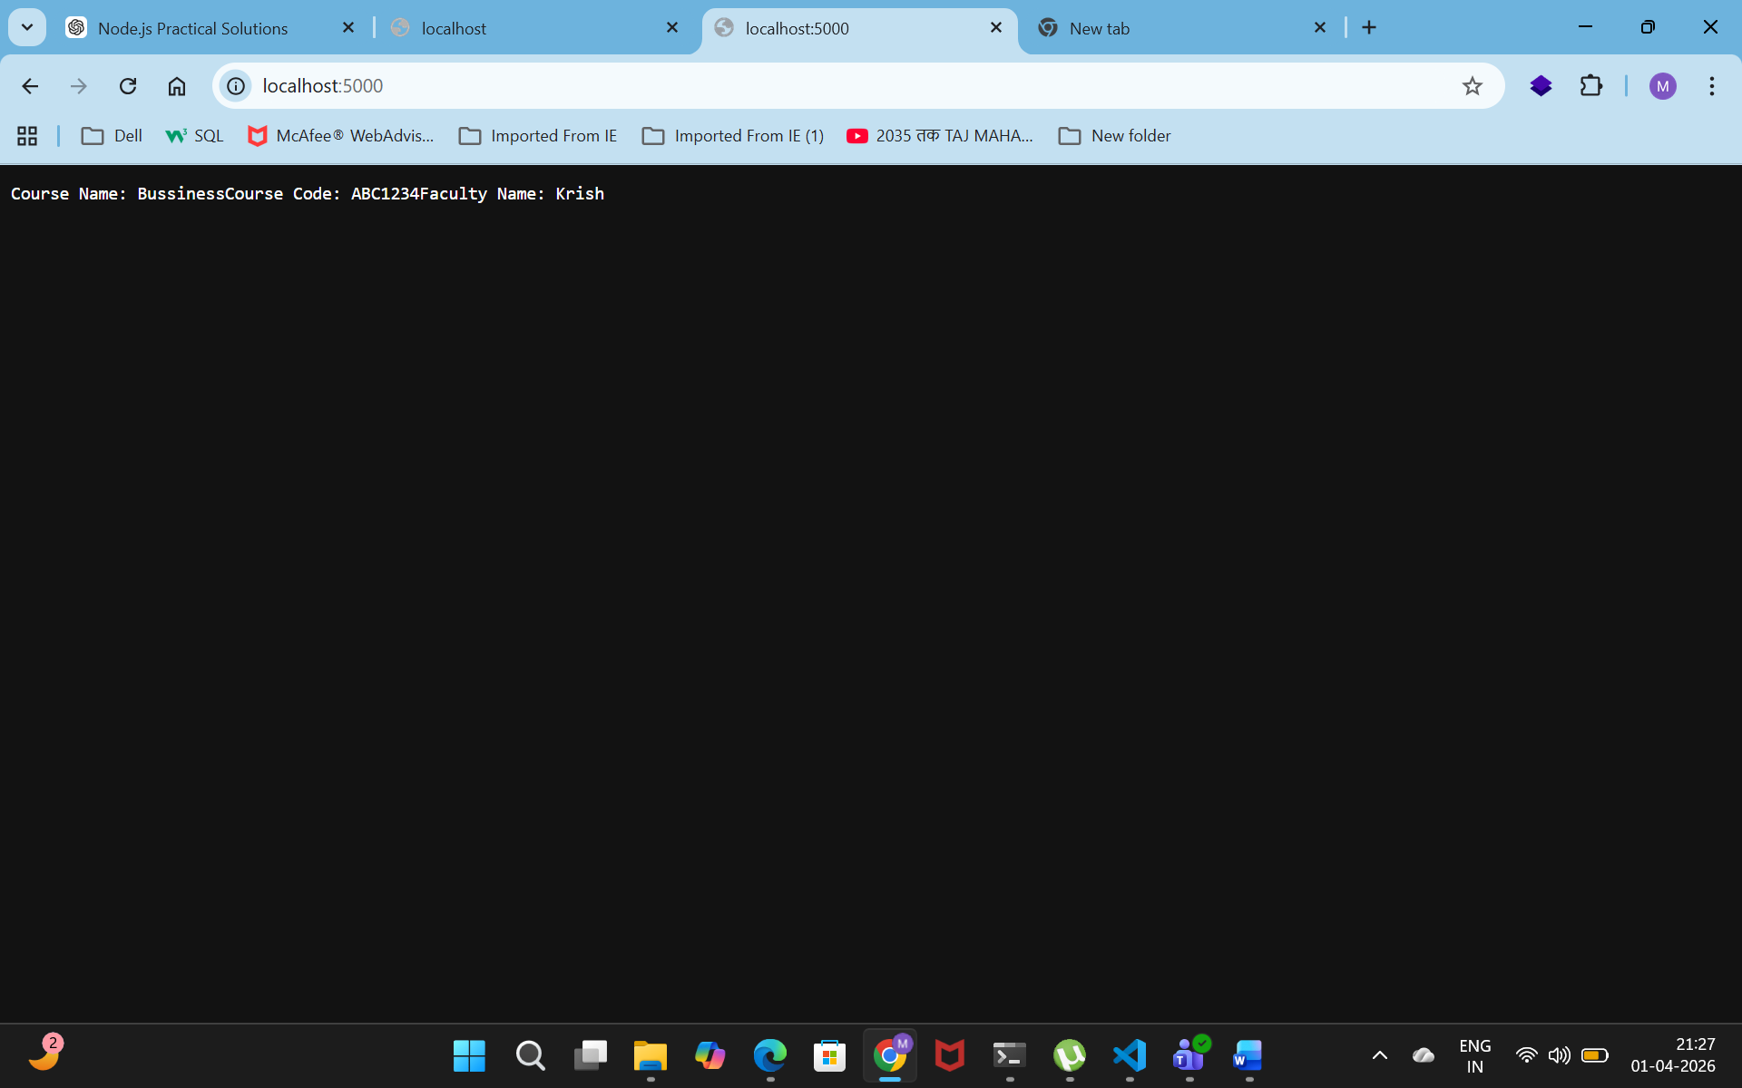

3. Write a Node.js program that accepts five numbers as arguments and displays the count of odd numbers and even numbers.

Code:
var http = require('http');
http.createServer(function(req, res) {
var args = process.argv;
var even = 0;
var odd = 0;
for(var i = 2; i < args.length; i++) {
var num = parseInt(args[i]);

if(num % 2 == 0)
even++;
else
odd++;
}
console.log("Even Count: " + even);
console.log("Odd Count: " + odd);
res.end();
}).listen(5000);

console.log("Server running...");

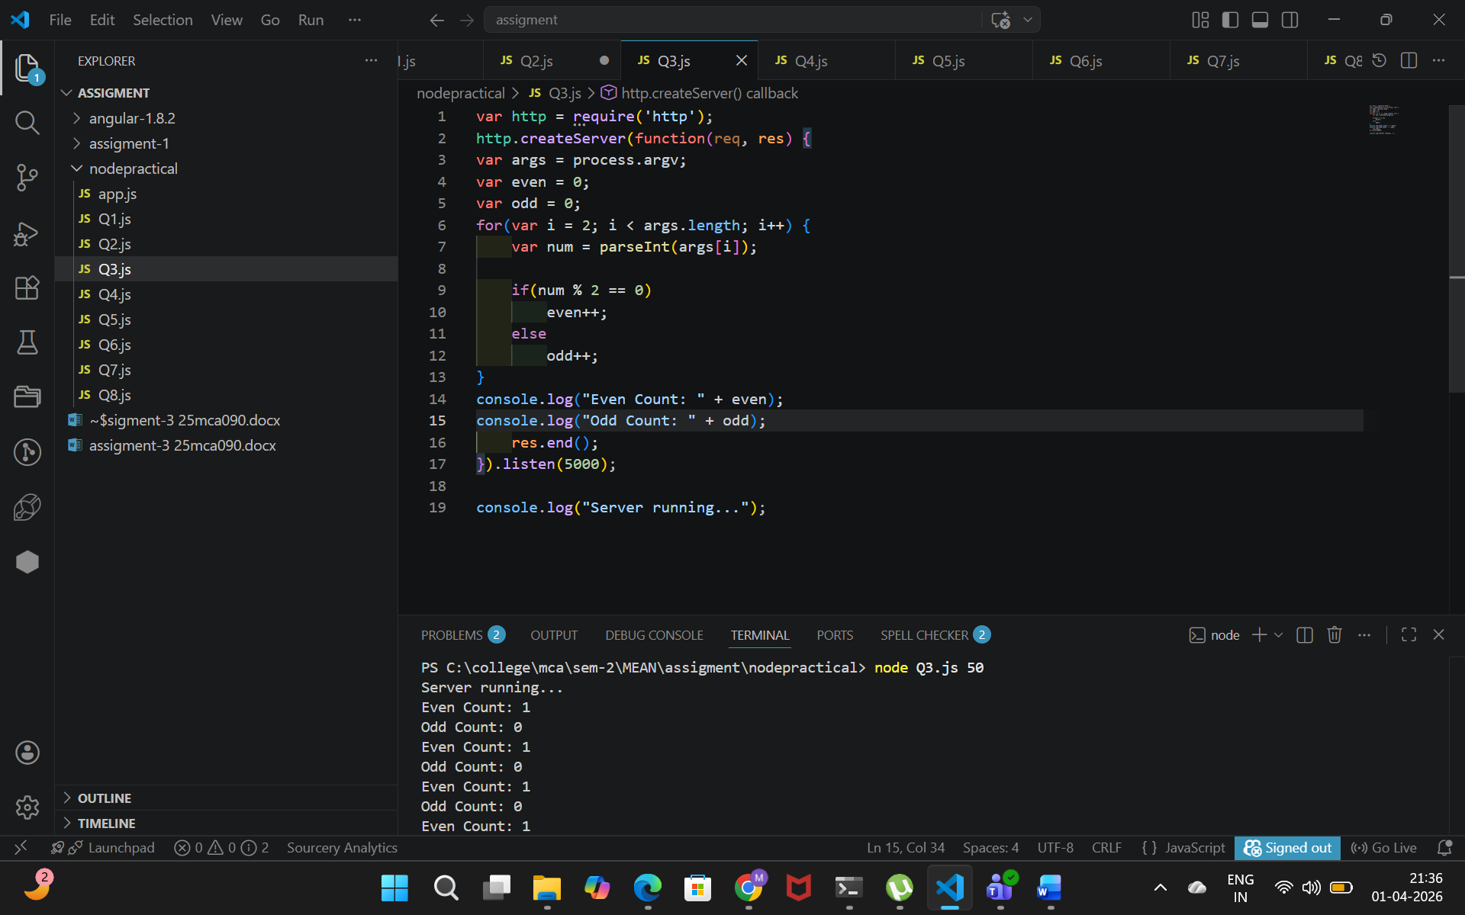

Output:

4. Develop a basic HTTP server that responds with "Welcome to the NodeJS App” to any request.
Code:
var http = require('http');

http.createServer(function(req, res) {
res.write("Welcome to NodeJS App");
res.end();
}).listen(3000);

console.log("Server running...");

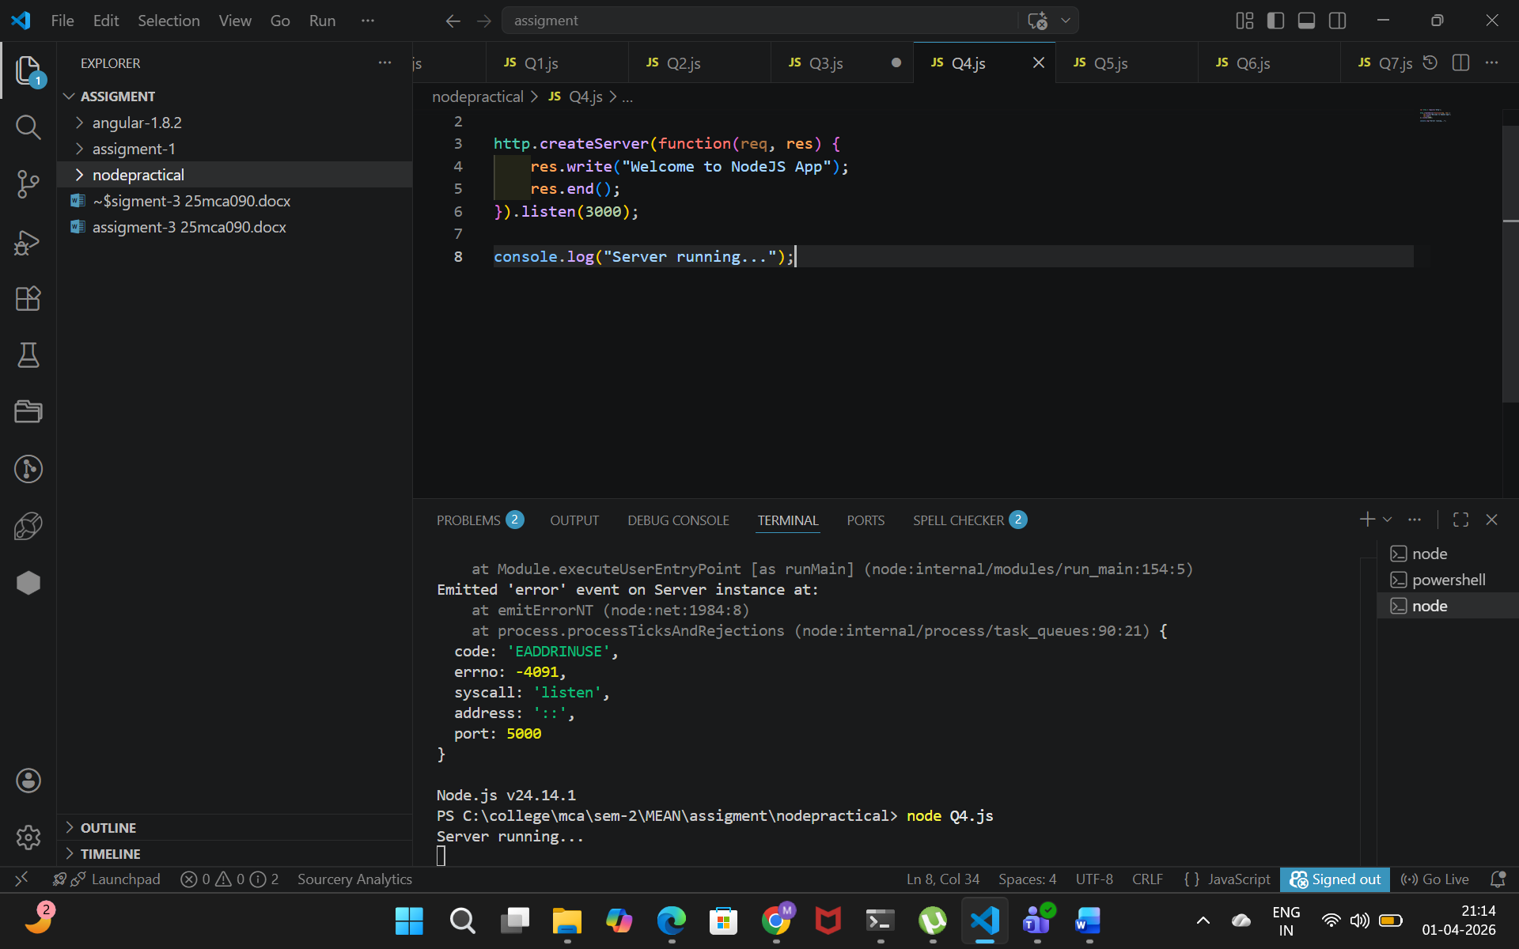
Output:
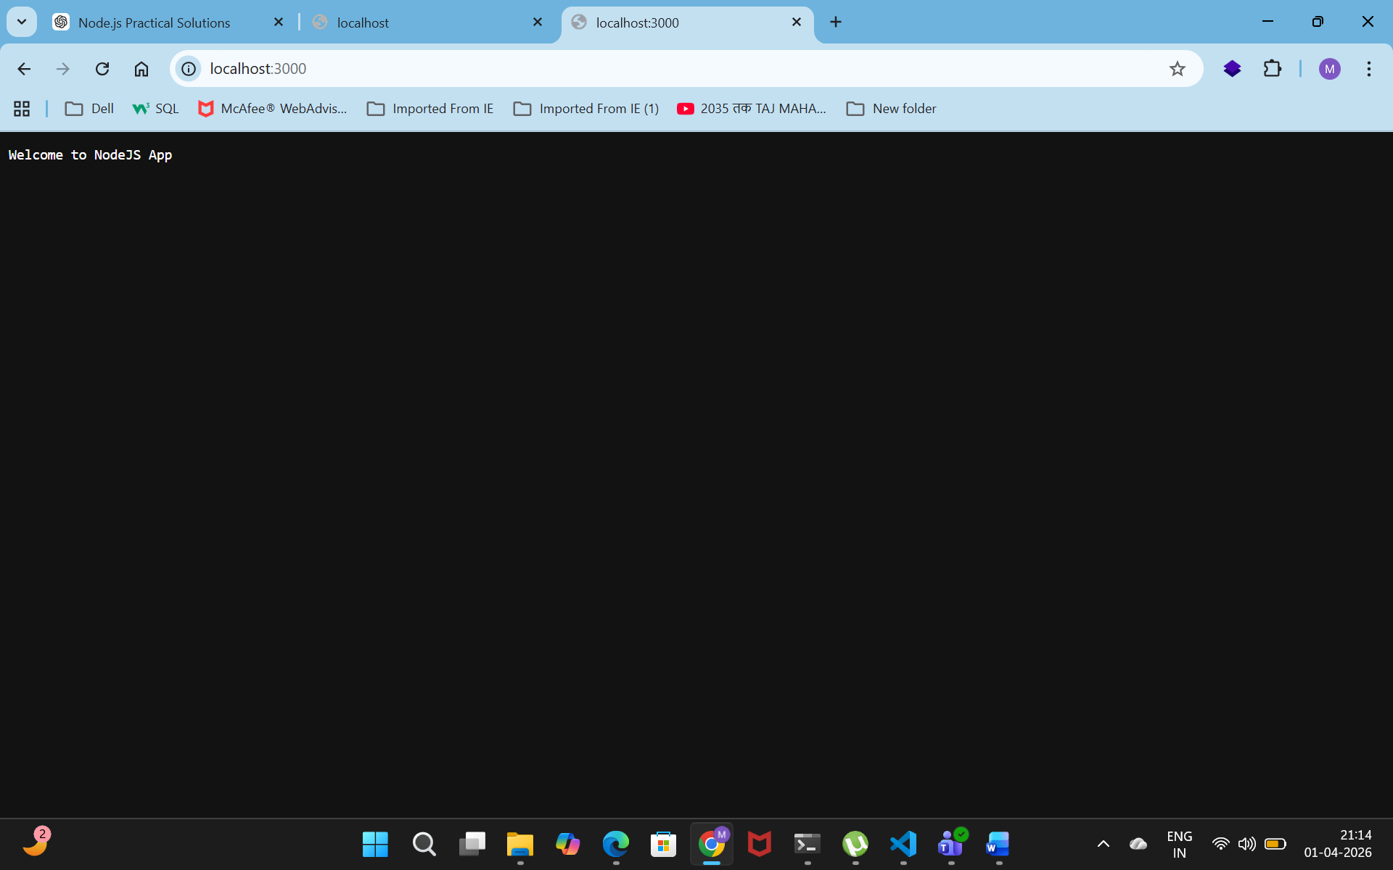
5. Develop a basic HTTP server that responds with “Welcome to Home/Student/Faculty” according to request sent in the URL with a different route - /home, /student, /faculty.

Code: var http = require('http');

http.createServer(function(req, res) {

if(req.url == "/home")
res.write("Welcome to Home");
else if(req.url == "/student")
res.write("Welcome to Student");
else if(req.url == "/faculty")
res.write("Welcome to Faculty");
else
res.write("Hello from Server");

res.end();

}).listen(5000);

console.log("Server running...");

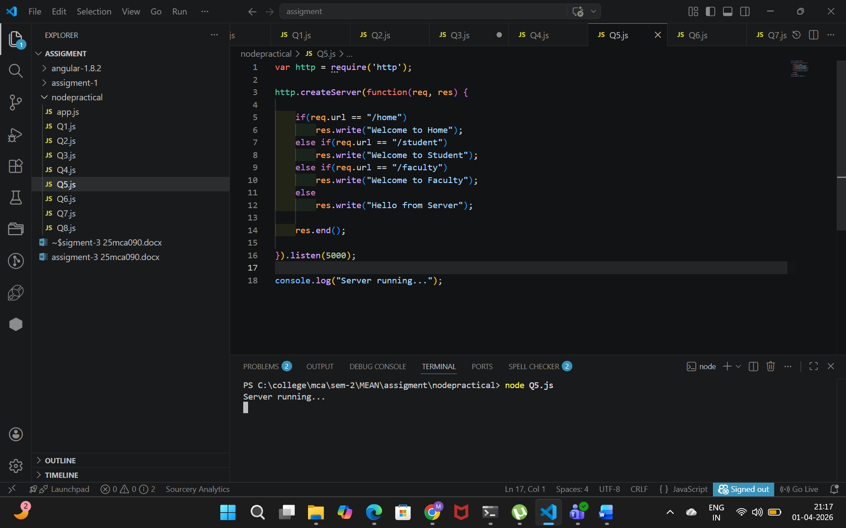

Output:
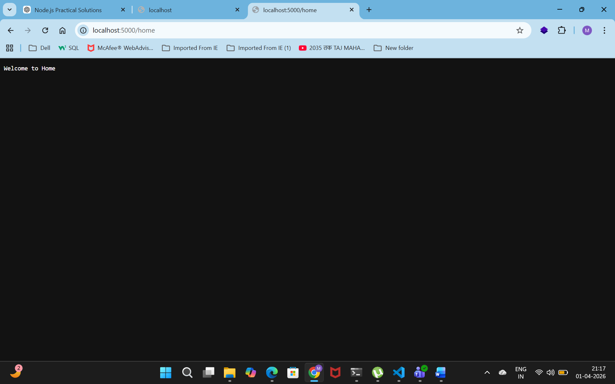
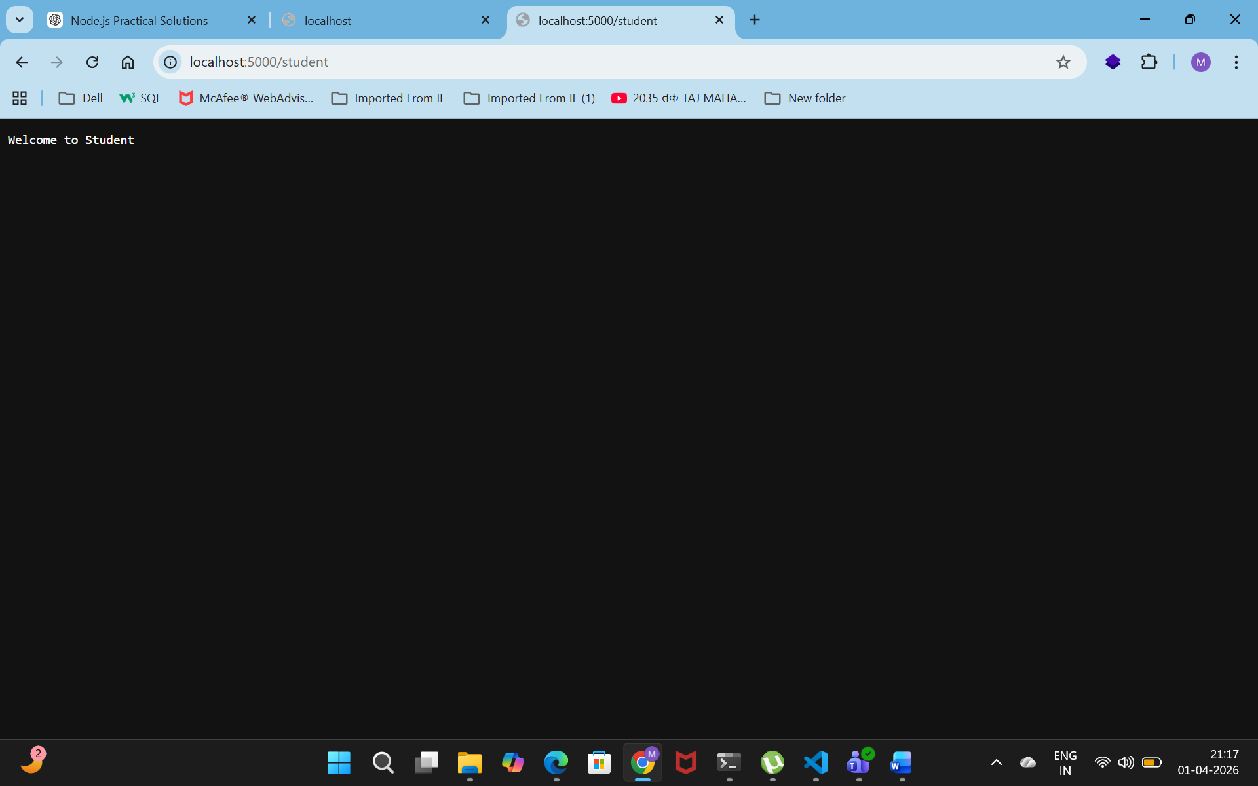
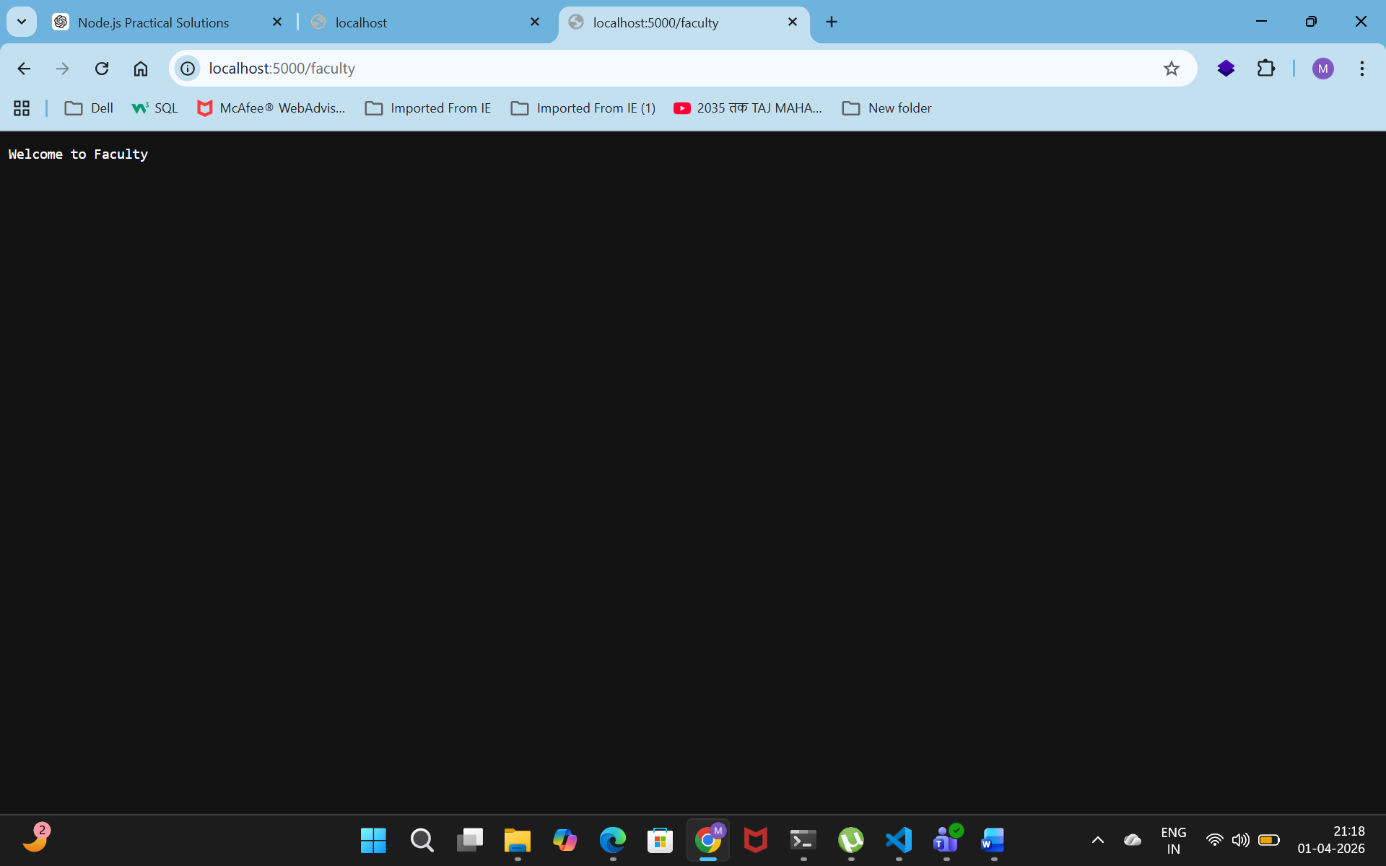

6. Develop basic HTTP server to perform Math Operation (+,-,*,/) according to request sent in the URL (/Add,/Sub,/Mul ,/Div). Also display the result with Number1, Number2, Result, Greater Number, Smaller Number). Consider dynamic user input as a number from the argument.

Code:
var http = require('http');

var n1 = 10;
var n2 = 5;

http.createServer(function(req, res) {

if(req.url == "/add")
res.write("Addition = " + (n1 + n2));
else if(req.url == "/sub")
res.write("Subtraction = " + (n1 - n2));
else if(req.url == "/mul")
res.write("Multiplication = " + (n1 * n2));
else if(req.url == "/div")
res.write("Division = " + (n1 / n2));
else
res.write("Use /add /sub /mul /div");

res.end();

}).listen(5000);

console.log("Server running...");

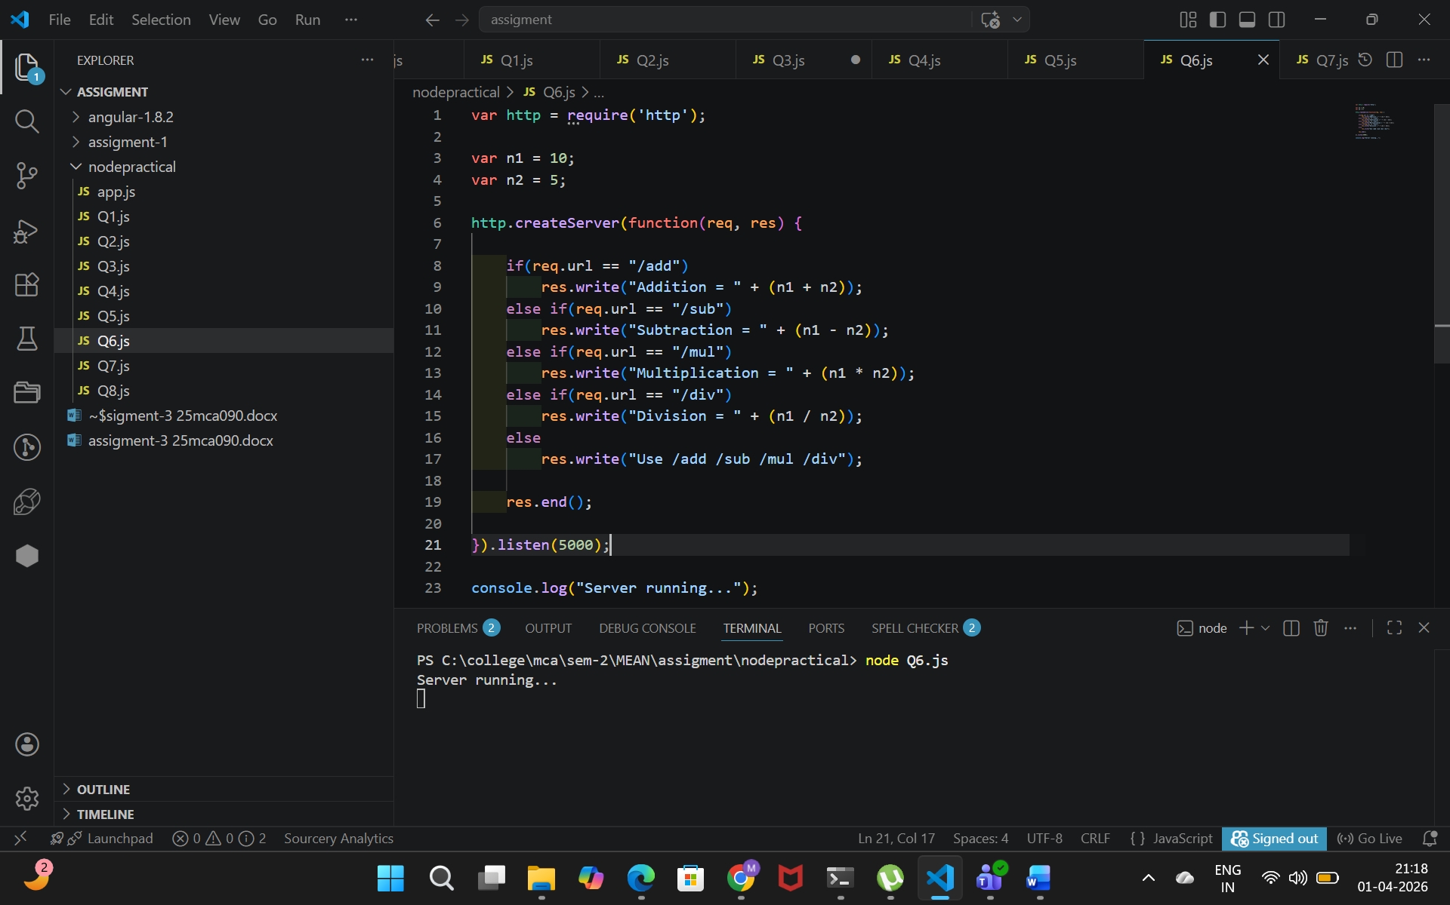

Output:
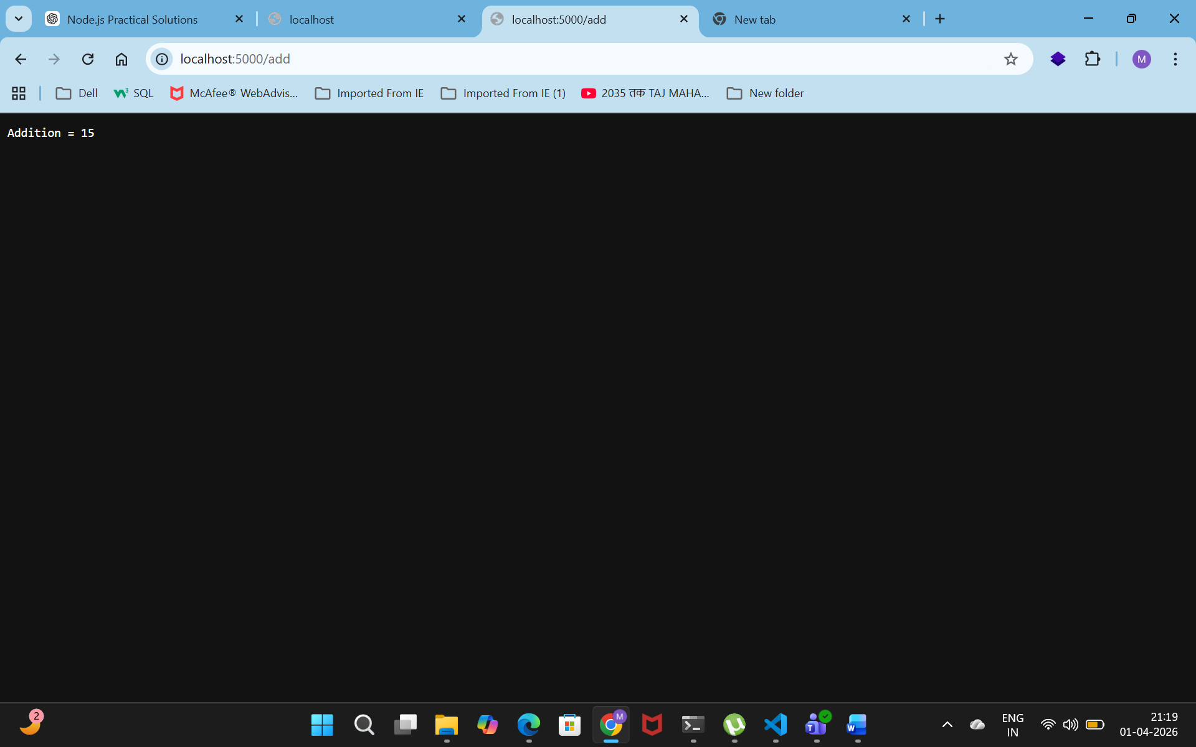
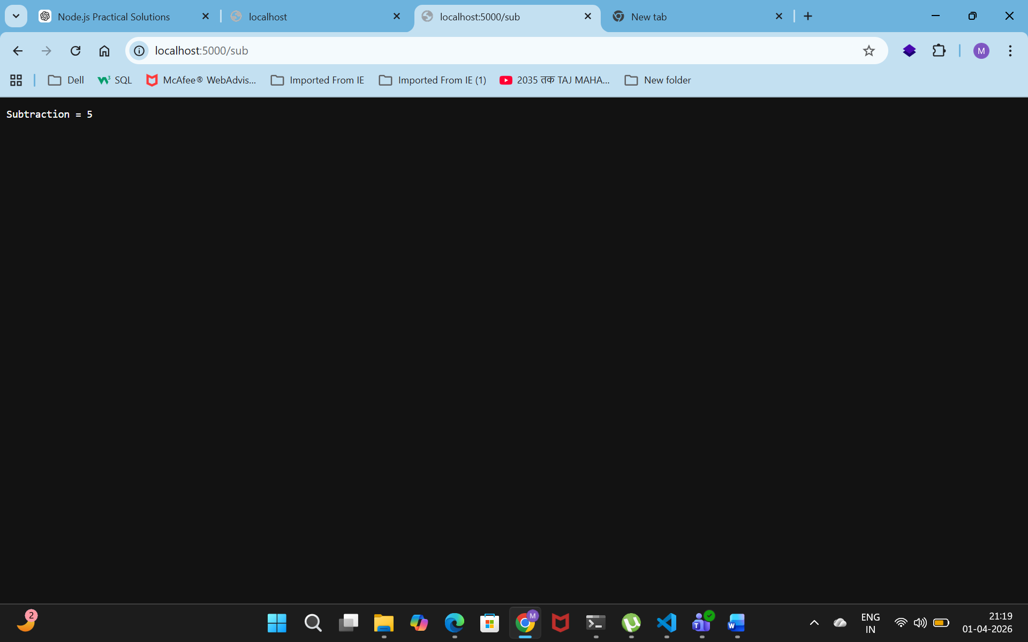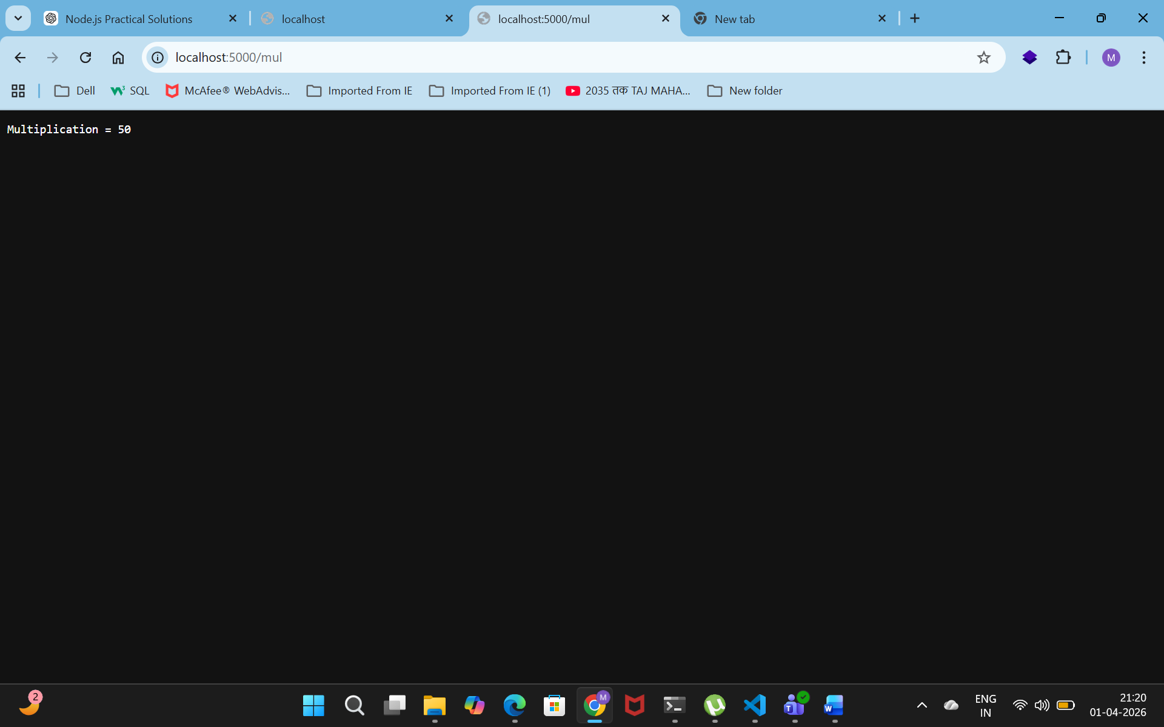
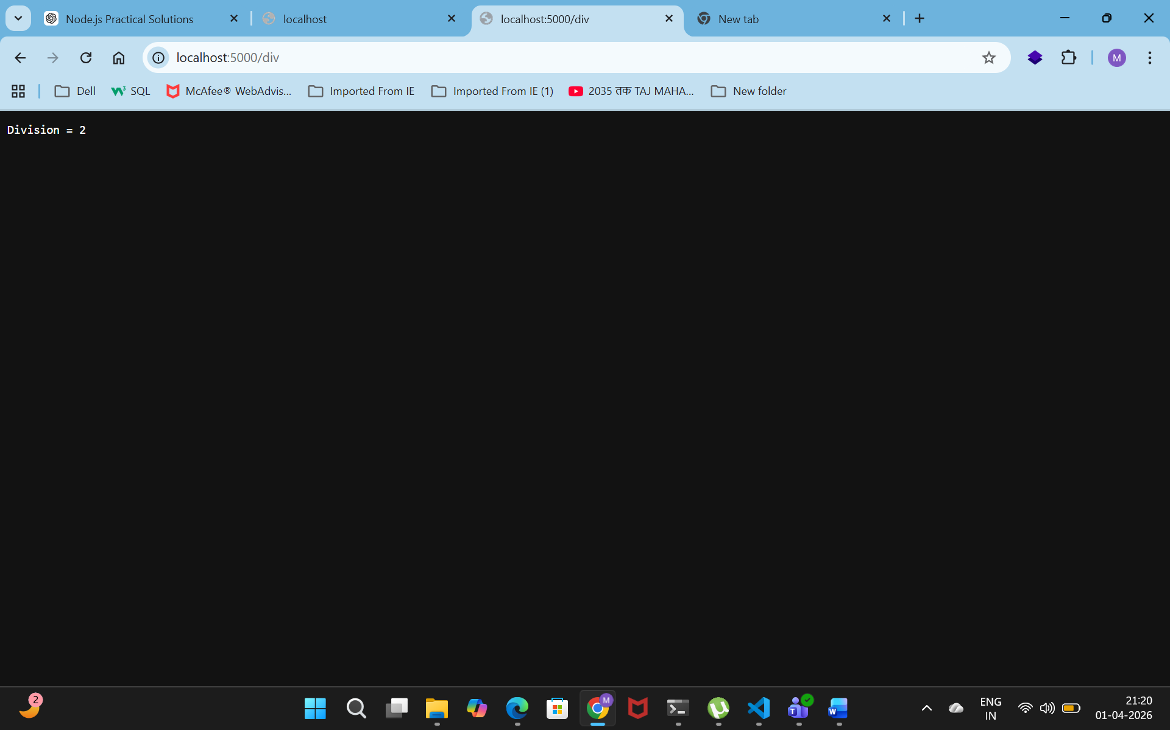

7. Develop basic http server to take the number1, number2 and operator from the url with querystring and display the result.
Code:
var http = require('http');
var url = require('url');

http.createServer(function(req, res) {

var q = url.parse(req.url, true).query;

var n1 = parseInt(q.n1);
var n2 = parseInt(q.n2);

var result = n1 + n2;

res.write("Result = " + result);
res.end();

}).listen(5000);

console.log("Server running...");
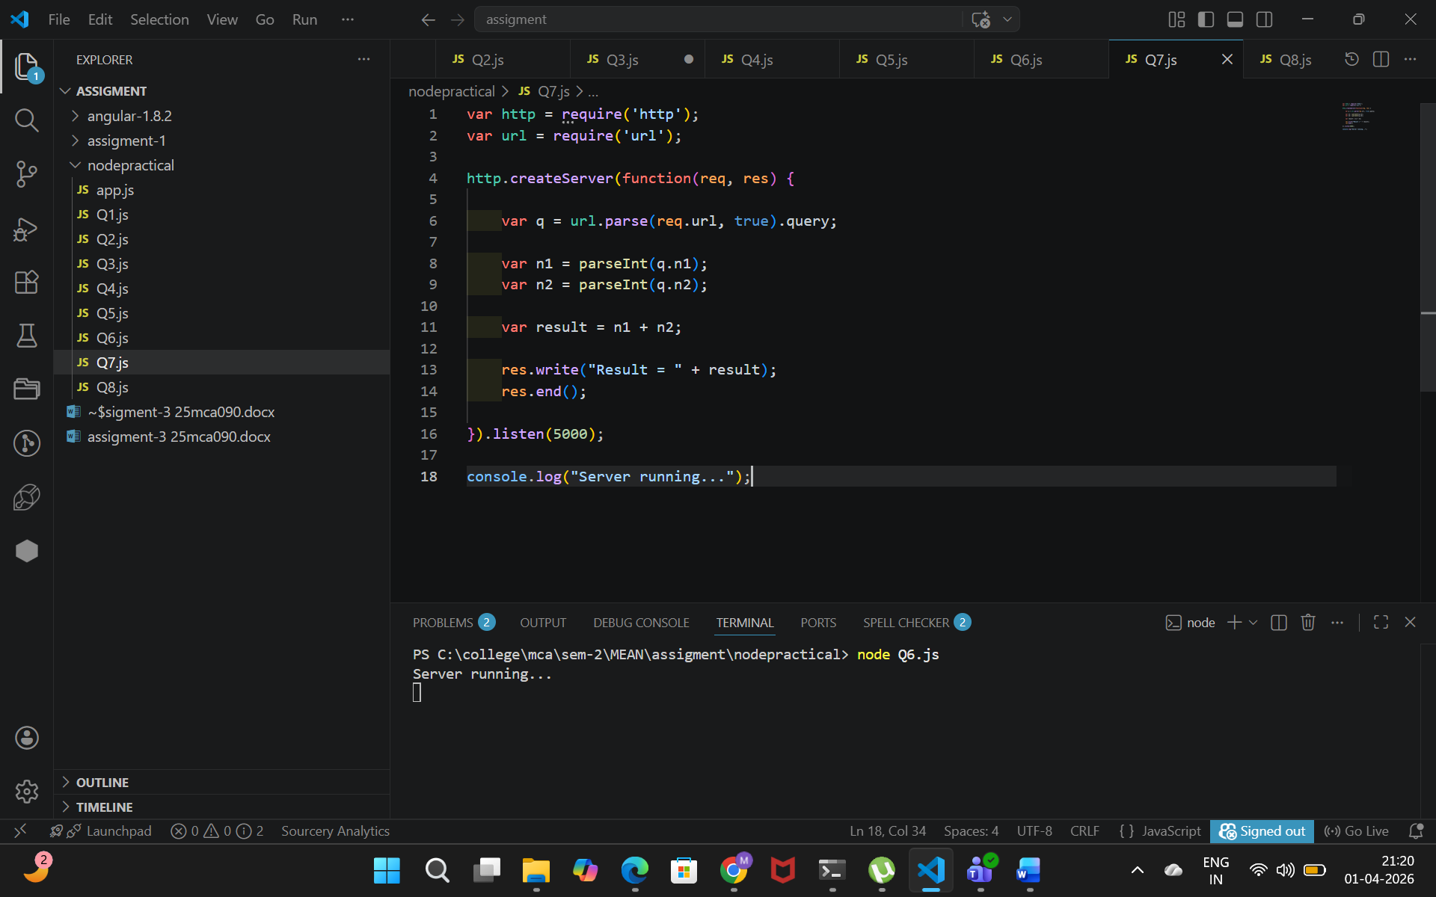

Output:
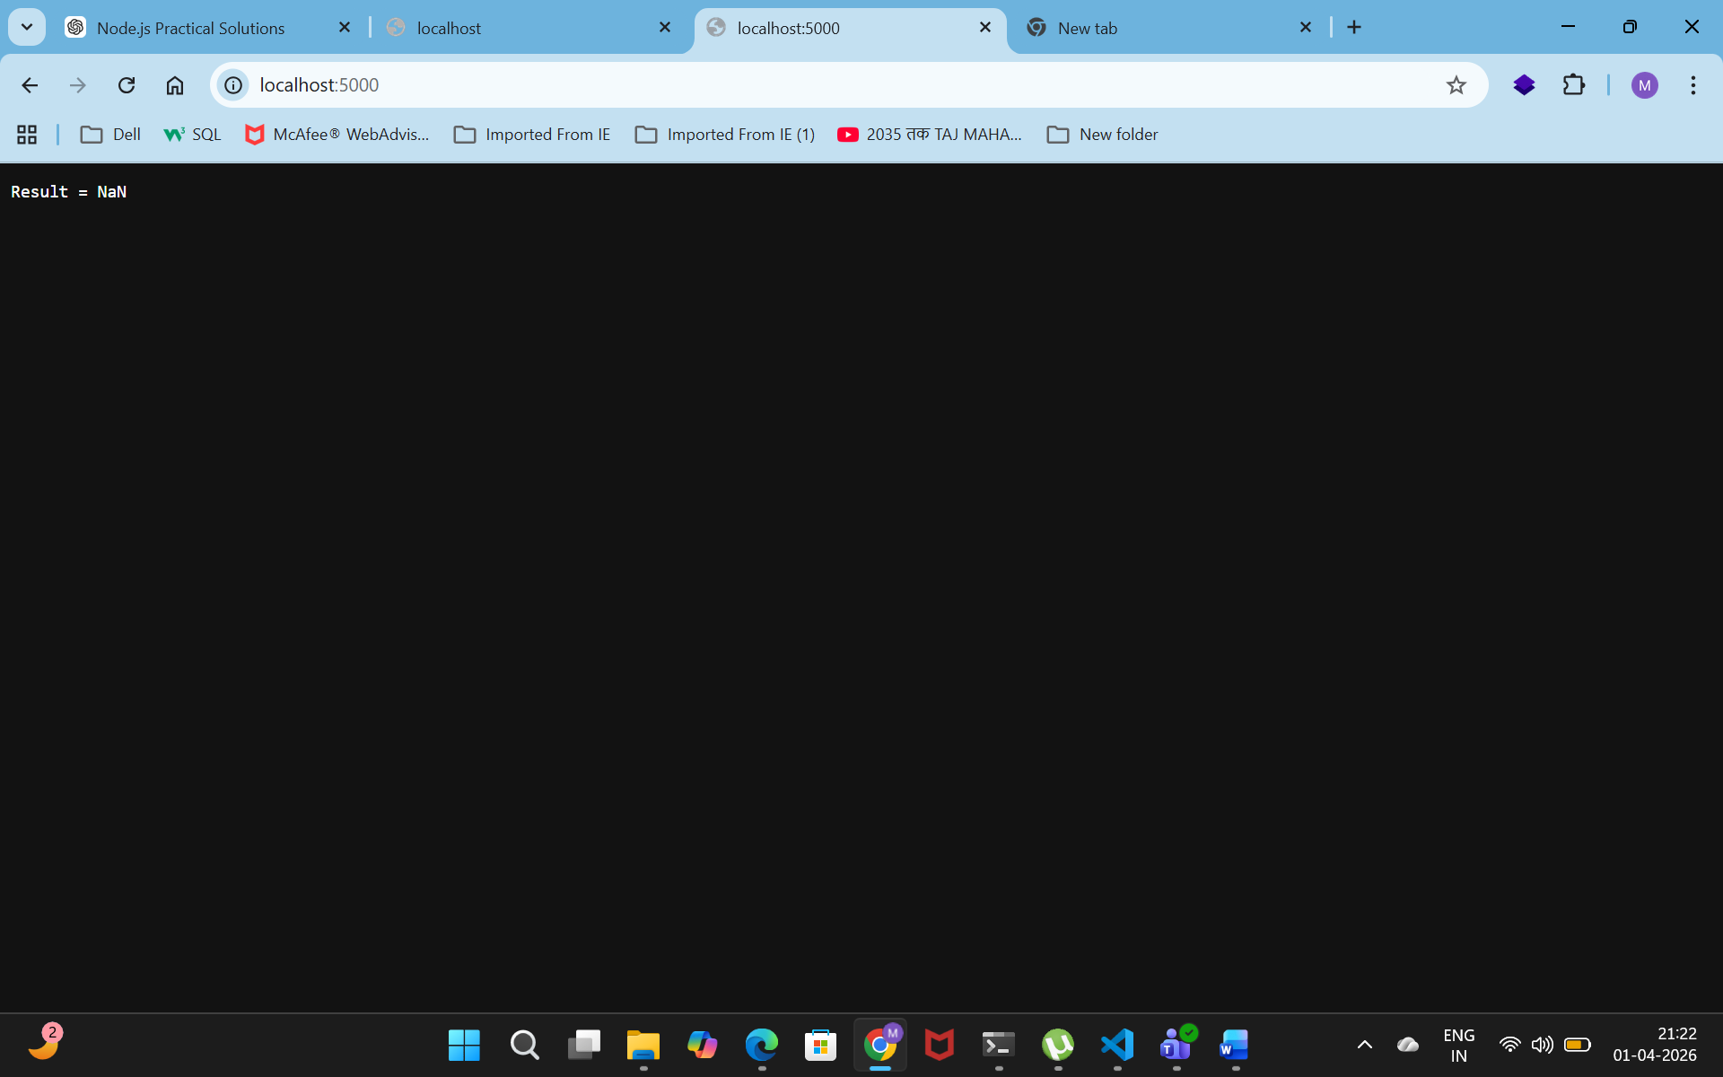

8. Develop HTTP server to display user details with /userData request. (Consider the data in JSON format)

Code:
var http = require('http');

http.createServer(function(req, res) {

if(req.url == "/userData") {
var user = {
name: "Krish",
course: "MCA",
city: "Rajkot"
};

res.write(JSON.stringify(user));
}
else {
res.write("Invalid URL");
}

res.end();

}).listen(5000);

console.log("Server running...");
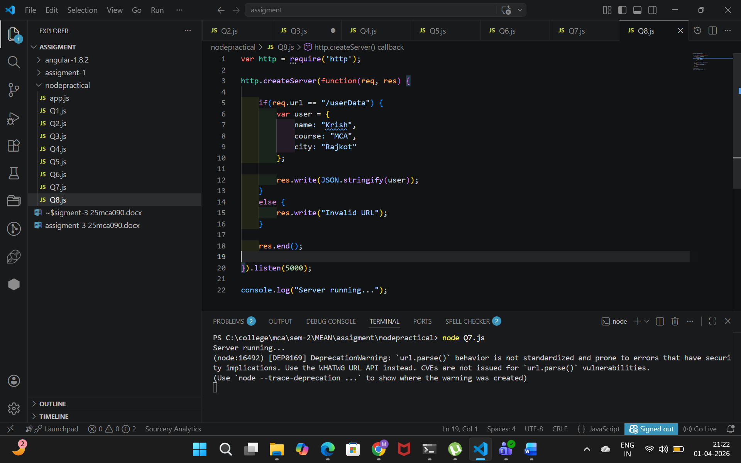
Output:
